THE MEDICAL SCHOOL
The Medical School of ZZU is one of the three earliest universities that conduct full English-medium undergraduate clinical medicine in China.
• One of the earliest Chinese medical higher education institutions recognized by WHO (World Health Organization) and approved to offer master and doctor degree programs in China.
• One of the earliest universities offering EMI (English Mediated Instruction) medical programs in China.
• More than 1000 undergraduate students have completed their medical study with degrees since 2000.
• For Now, about 940 undergraduate students are studying medicine in Zhengzhou Universities who are from Nepal, India, Pakistan, Bangladesh, Saudi Arabia, Syria, Eritrea, Botswana, Myanmar, Peru, Maldives, Zimbabwe, the U.S.A., Canada, Austria, the UK, etc.

AFFILIATED HOSPITALS OF ZZU
The comprehensive strength of ZZU's 9 affiliated hospitals ranks top in China.
• The 9 affiliated hospitals of ZZU include 8 Grade III Class A hospitals and 1 Grade II Class A hospital.
• As for the 9 hospitals, there are more than 15,000 beds, reaching 400,0000 out-patients per year.
• With strong and profound technical capability and advanced equipment, the hospitals could have 300 international students of undergraduate clinical medical major do their internships at the same time.

FACULTY
The Clinical Medicine Department of ZZU has strong teaching resources.
• The school owns 2 academicians, 19 special professors at the provincial level, 48 guest professors,44 Ph.D.supervisors, 269 MA student supervisors, 150 doctor teachers and 397 master teachers.
• With over 30% of the teachers having studied or worked overseas, full English-medium classed can be conducted absolutely.
• ZZU invites outstanding graduates to be back to school as the tutor of some crucial and key courses.

LAB FACILITIES
ZZU provides a great platform for students' clinical stage skills training with its complete and advanced laboratories and experimental centers.
• ZZU has invested to build up specified clinical skills experimental centers for international students, including Clinical anatomy laboratory, Surgical skill laboratory, internal medicine skills laboratory etc.
• These laboratories are set up with Simulated Operation Room, Animal Laboratory, Electronic patient training room, Simulated ward, ICU ward, Clinical Specimen Exhibition Hall etc.
• These advanced teaching instruments and equipment covers various experimental teaching functions in internal medicine, Surgery, Obstetrics and Gynecology as well as Pediatrics etc.

REPUTATION
The clinical medicine program in ZZU ranks top one percent in ESI globally and hold many advantages.
• Students are to be taught with clinical and clinical interpersonal skills and get contact with patients at early stage.
• The theoretical teaching of the clinical medicine combines well with students' clinical experiences arranged by ZZU. ZZU specially set up a Clinical Skills Training Centre for international students to master clinical skills so that they can receive timely and effective training.
• ZZU employs both domestic and international experts and professors to give lectures and students would have access to global patients to acquire practical and various experiences from different emergency cases.

MAIN COURSES
The clinical medicine program offers about a number of medical courses for students during their study in ZZU: Anthroponomy, Histoembryology, Physiology, Biochemistry, Pharmacology, Pathology, Preventive Medicine, Microbiology and Immunology, and Diagnostics (physical diagnosis and laboratory diagnosis), Internal Medicine, Surgery (including the Survey of Surgery), Obstetrics-gynecology and Pediatrics, etc.

THE CURRICULUM
During the 6 years' study, there are 12 semesters for the MBBS program. In the last year (semesters 11 and semester 12), students will have their internship in China or other qualified hospitals.

2nd Year | 3rd Semester | 4th Semester
2nd Year | General Introduction to China,  Histology & Embryology,  Regional Anatomy,  Cell Biology,  Neuro-Biology,  Elementary Chinese(Ⅱ-A）  (Total Credits 25) | Physiology,  Biochemistry,  Medical Microbiology,  Medical Immunology,  Elementary Chinese(Ⅱ-B）  (Total Credits 26)
3rdYear | 5th Semester | 6th Semester
3rdYear | Pathology,  Medical Ethics,  Oncology Foundation,  Human Parasitology,  Medical Genetics,  Medical English,  Medical Chinese (Ⅰ)  (Total Credits 25) | Pathophysiology,  Pharmacology,  Clinical Pharmacology,  Medical Psychology,  Preventive Medicine,  Epidemiology,  Medical Chinese(Ⅱ)  (Total Credits 26)
4thYear | 7th Semester | 8th Semester
4thYear | Introduction to General Medicine,  Image Diagnostics,  Experimental Diagnostics,  Nuclear Medicine,  General Surgery,  Clinical Diagnostics,  Evidence Based Medicine,  Medical Chinese(Ⅲ)  (Total Credits 26) | Internal Medicine,  Surgery,  Pediatrics,  Infectious Disease,  Medical Chinese(Ⅳ）  (Total Credits 26)
5thYear | 9th Semester | 10th Semester
5thYear | Gynecology and Obstetrics,  Psychiatry,  Ophthalmology,  Otolaryngology,  Dermatology&Venereology,  Stomatology,  Neurology,  Forensic Medicine,  Geriatric Medicine,  Rehabilitation Medicine,  Emergency Medicine,  Plastic Surgery,  Minimally Invasive Treatment,  Social Medicine  (Total Credits 26) | Medical Statistics software,  Ultrasonic Diagnostics,  Health Education,  Oncology Foundation Clinical,  Interpersonal Communication,  Clinical Lecure,  Clinical Skills Training  (Total Credits 20)

ACCOMMODATION
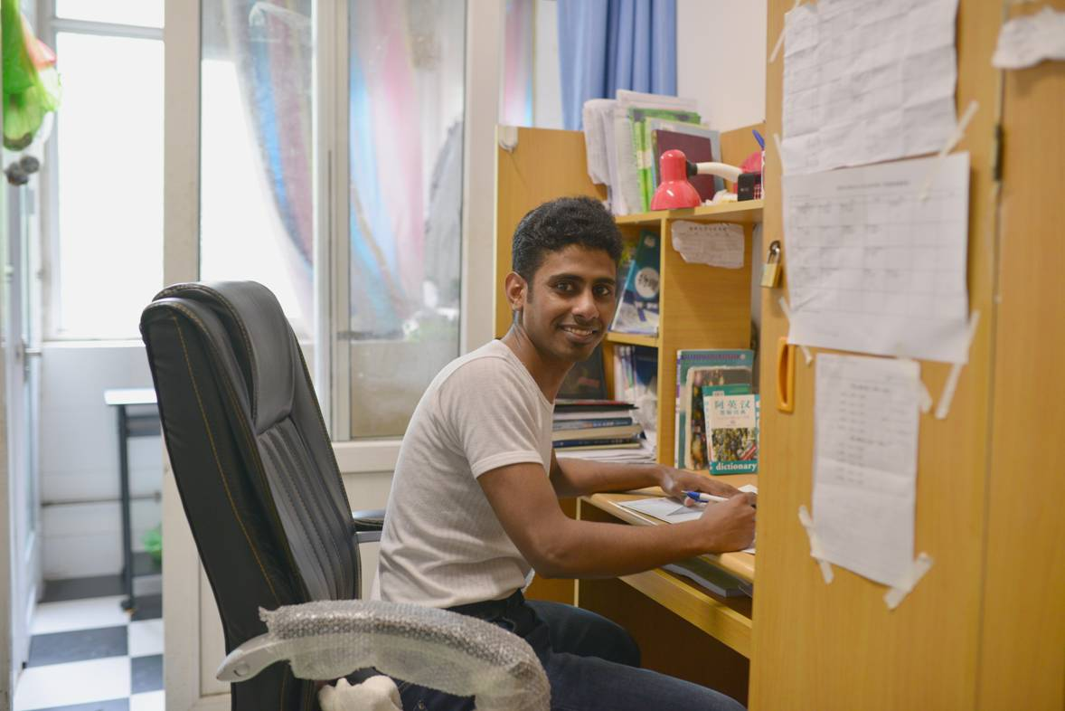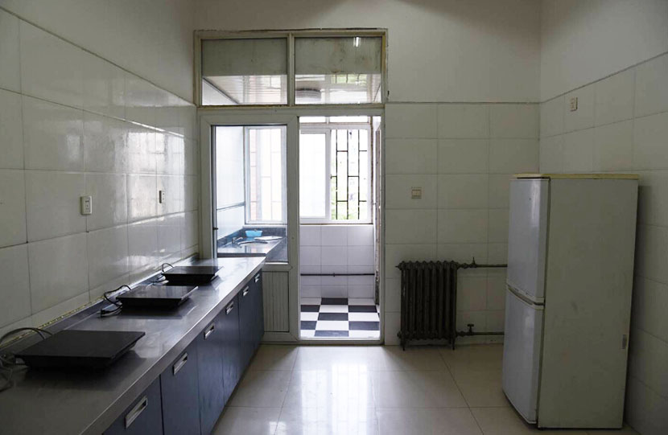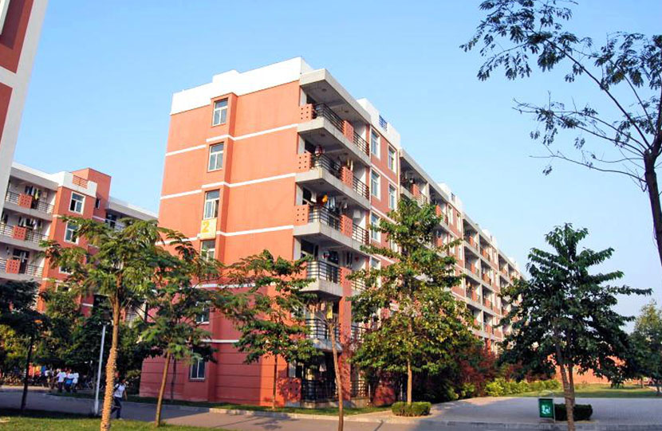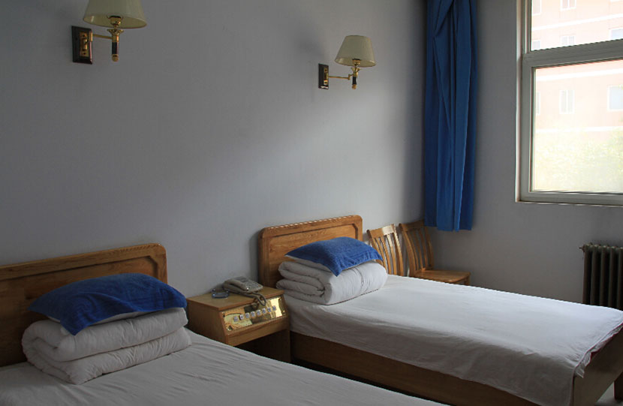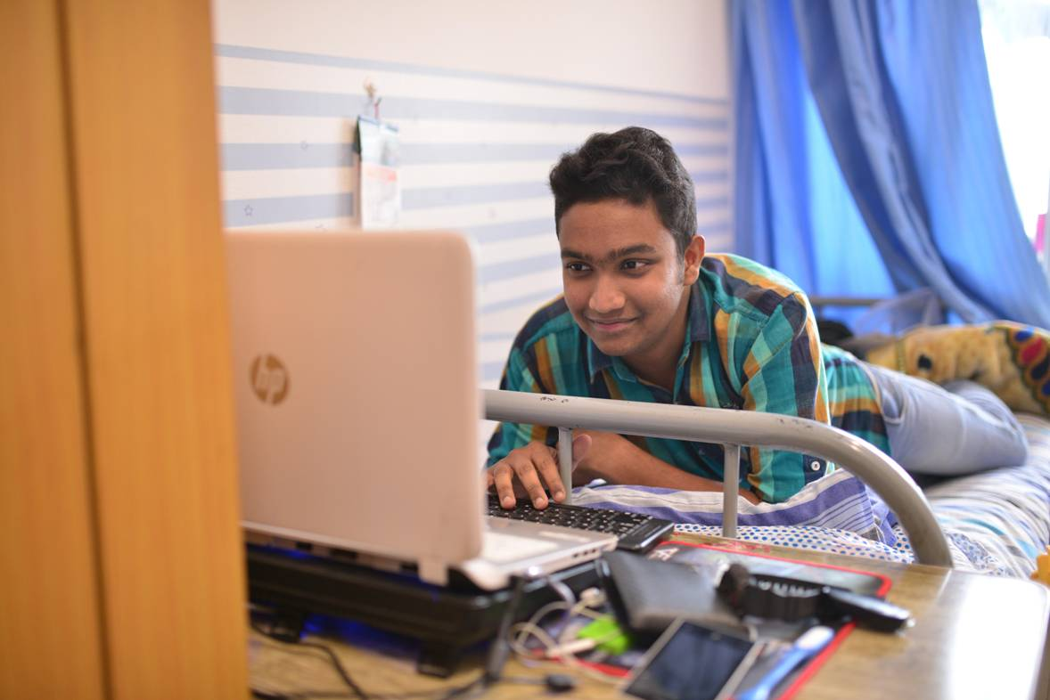

lIBRARY
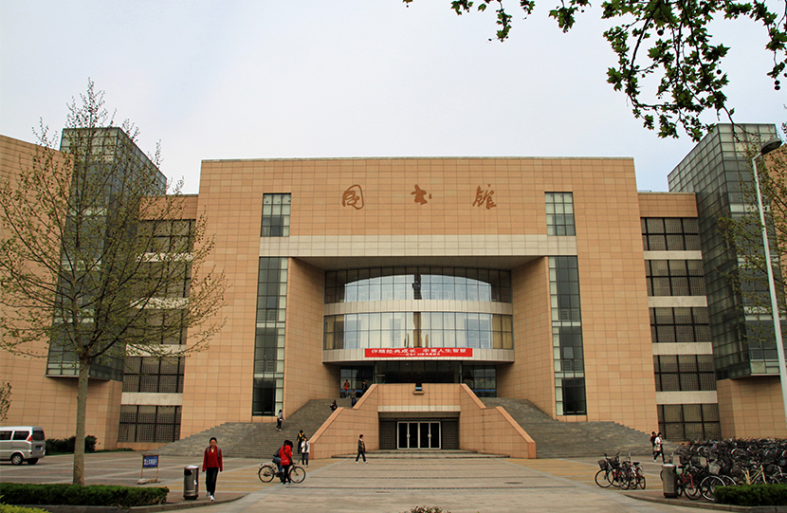

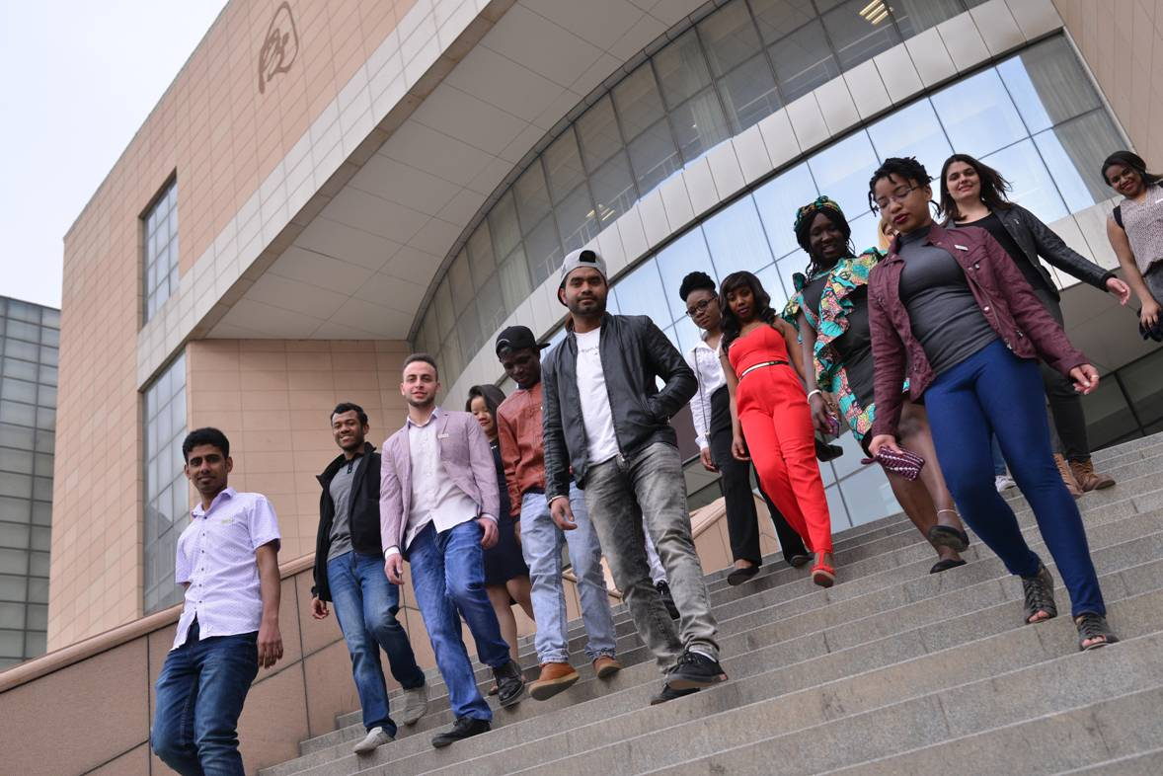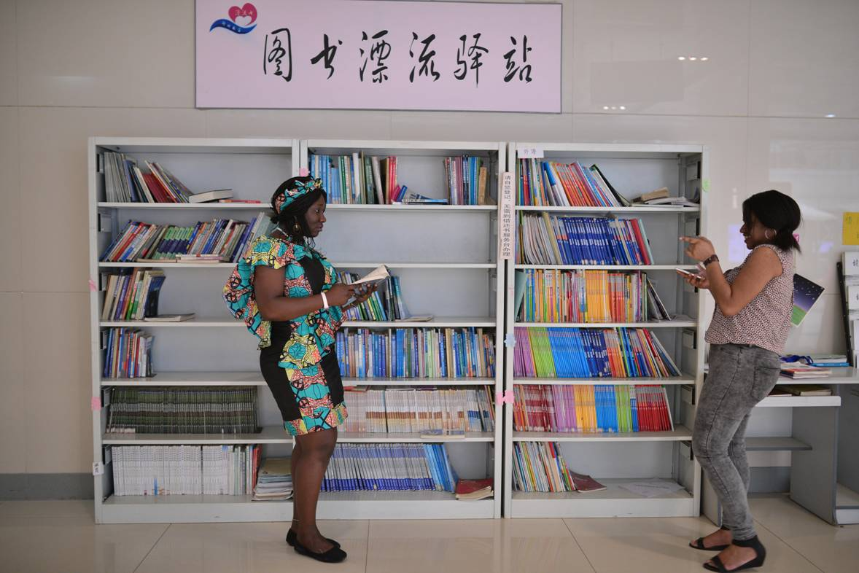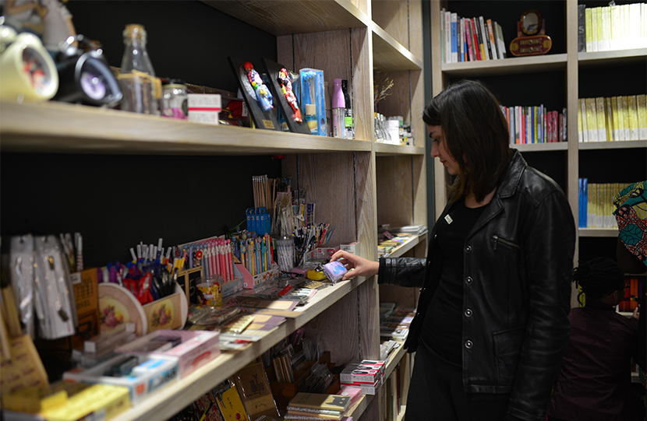

SPORTS

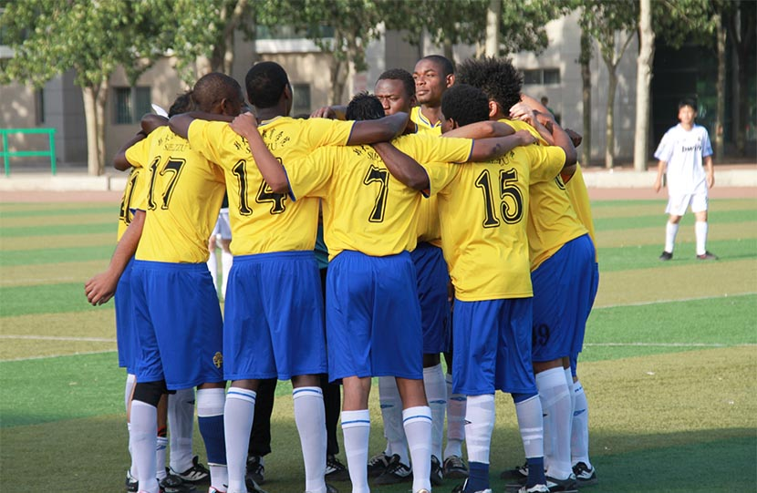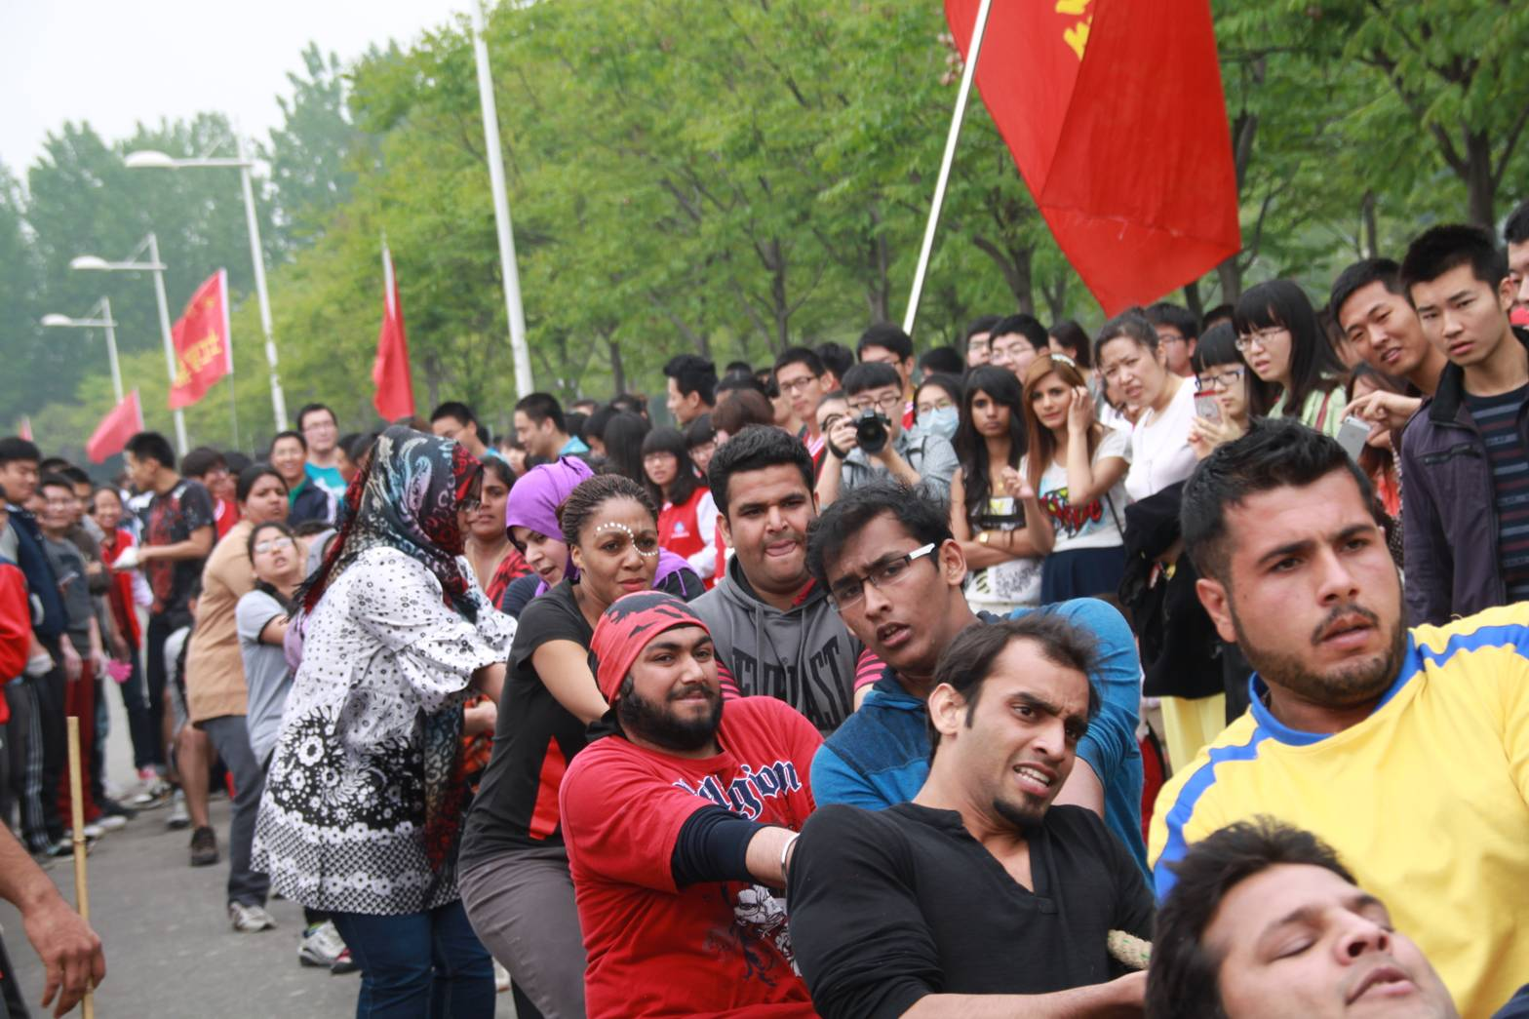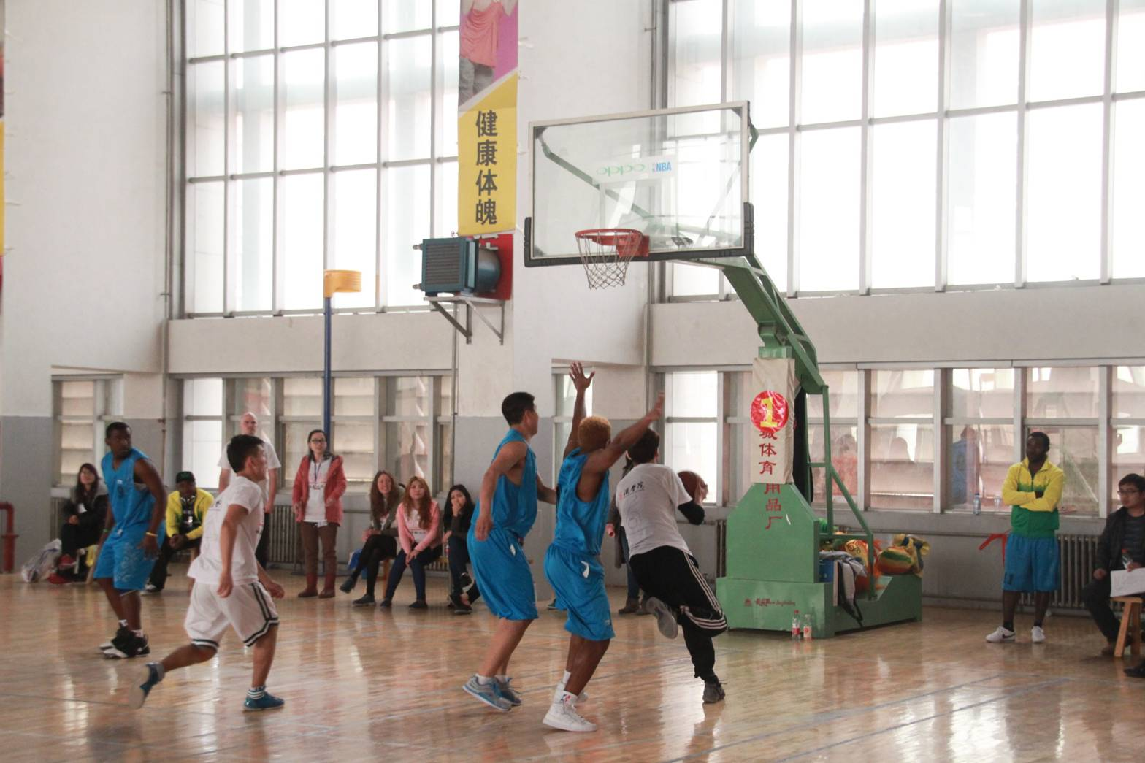

Training & Internship
