SICAS “Plus Service Package” Agreement
Party A: SICAS
Party B: Student
SICAS “Plus Service Package” Application Procedure:
1st, Party B email Party A the scanned copies of documents including but not limited the following, and complete the first Step 1, Step 2, Step 3 on www.sicas.cn online with our help.
A, Photocopy of valid passport,
B, Graduation certificate of high school,
C, Academic transcript of high school,
D,Two blank pages of the passport ( For the regarding authority must make sure that there are at least two pages on the passport for the Chinese Embassy to stick the Visa paper and Immigration to stick the resident permit paper.)
F _________others
2nd, Sign the agreement and make the payment of 3000 USD for SICAS “Plus Service Package”
3rd, Party B Track Admission Status and the scanned copy of Admission Letter and JW202 form on the system (or by email) in three to fifteen working days.
4th, Receive the original Admission Letter and JW202 form by post, and then accept SICAS Visa online Application Training, apply for Visa.
5th, Accept SICAS Pre-departure training and then fly to China.

Party A 's responsibility & Guarantee :.
- Making a Choice
- Applying Online & Track Admission Status
- Admission Letter Delivery
- Accommodation Booking
- Study Abroad Planning
- Admission Guarantee Service
- Airport Pick-up
- Resident Permit Guarantee Service
- University Transfer Service
- Future Career Consultation
_______________________Others
01. Admission & JW202 Guarantee
- 100% Guarantee the Admission for Party B before 29th(Date), _Jan_(Month), 2013, from one of the following universities / subjects, taught in English.
  - Donghua University/ BBA
  - Shandong University/ BBA or MBBS
  - ------------------------------------------
If Party A fails to do it,, the above payment of will be 100% refund to Party B within 10 working days or Party A will be responsible to enroll him into another university which is agreed by him .
- Admission Speed-up
- You may get your Admission Letter in 24-72 hours for some universities.
- Visa Application Preparation
- SICAS help you to prepare and post all the original Visa Application Documents requested by China Embassy and keep supervising in each step to support you to get your Visa easier and faster.
- SICAS offer you Online Visa Application Training (worth $300) for free to make your way of visa application smoother.
- Pre-departure Training
SICAS offer you Online Pre-departure Training (worth $300) for free to train you
- Accommodation arrangement
- Although dorm on campus of each university is always limited, SICAS will arrange it if you need.
- SICAS will help you “rent an apartment” in a safe district near your campus if you need.
- SICAS also help you to check and sign the Apartment Renting Agreement between you and your Landlord to avoid any Renting abuse in the future, and make sure all the items will be right within the define of the Law of Chinese Central Government & Local Government, and also the regulation of Universities and Police Station, PR.C.
- Airport Pick-up
- With SICAS “Plus Service Package”, SICAS staff will pick up you on 24/7 hours services at any time, even in the mid-night in China, and then send airport pick up pictures immediately to your parents in your home-country via email or short message on the very minute of your’ safe arrival in China. Most of the time, the drivers are English speaker.
07. Registration on Campus
- SICAS Student Service Team Member will bring you to the regarding offices one by one to do the Registration according to each university’s registration procedure, to avoid your tired hiking on the campus, as we all know, China’s university campus are always as huge as a city.
- SICAS will also make sure your registration will be accepted by university, and there will not be any troubles.
08 Police Registration & Resident Permit
- SICAS make sure that each student will be done with Police Registration within the time duration defined by the law and also get the legal Resident Permit to study in China every year during their study in China. Both are compulsory for a foreigner’s legal stay in China, and requested by China Immigration and Police Station.
09 Medical Check in china
- This is compulsory and requested by China Immigration and Police Station for Resident Permit. SICAS help you do it at the right time for the necessary items and avoid the unnecessary payment.
Insurance in china
- This is compulsory and requested by Ministry of Education, P.R.China & Ministry of Foreign Affairs, P.R.China. SICAS make sure that you’ll get the right type of insurance and the insurance company that you’ve chosen can really help when the regarding issues arise.
11. New Students Orientation Week
- For the first week, SICAS arrange specific SICAS Student Service Team Member to take care of you whole week, 24/7. You will be assisted in shopping, banking, booking tickets and hotel, linking with all professional Departments, finding religious venues, etc. SICAS Student Service Team Members are fluent in English, Chinese and full of experience to handle any emergent issue for you.
- Longlive Parents-style Care
- SICAS offer to SICAS PLUS Service Package Students a four to six years 24 hours parents -style care for any urgent issue or accident of SICAS Students.

Party B 's responsibility :
Make the payment of 3000USD as SICAS “Plus Service Package”fee for the above services within on the same working day after signing this agreement, so that Party A will start the Guaranteed Admission Application Process for Party B.(otherwise Party B will have to pay for 100 usd as late fee / day to party A.)
Account Details:
1) 国内汇款（If you transfer money in China, then pls make payment to）：
账户名(Account Name)：青岛麟客国际教育咨询服务有限公司
账号(Account Number)：209112102481
开户行(Bank)：中国银行青岛高科技工业园支行营业部
2) 国际汇款（If you transfer money from abroad to China, then pls make payment to ）
Make all payments payable to: EduChinaLINK Co., Ltd. (Qingdao)
Account Info
Account Name: EduChinaLINK Co., Ltd. (Qingdao)
Account No.: 215612102488
Name of the bank: BANK OF CHINA QINGDAO HI-TECH INDUSTRIAL PARK SUB-BRANCH. QINGDAO CHINA
Swift code: BKCHCNBJ500
Company Info
Company: EduChinaLINK Co., Ltd. (Qingdao)
Address: Room1302, Building10 ,Zone B, Jin Ling Garden, Xian Xialing Road No.12, Laoshan District, Qingdao, Shandong, P.R. China
Tel: 86-532-88893256,86-18663920002,
Fax: 86-532-88893256
E-mail: service@sicas.cn, studyinchina@educhinalink.cn, lulu77585212002@yahoo.com
Then inform us that you have already transferred the fees to our bank account in both of the two ways:
- send an email to lulu77585212002@yahoo.com and sicasadmission@gmail.com
- send a short message to +86-18663920002 with your name, nationality, passport number, remittance sum and date (SAMPLE: Muhammad Hamza; Pakistani; AE6253789; $3800; June 30, 2009).
Others:
The students can choose if they would like to purchases any of the following services from SICAS:
1st, Another City airport pick up Service : ________________RMB
2nd, Students’ Family Member‘s Visa and Resident Permit Service: ___________________RMB
3rd, Assist on Personal Statement Writing__________________RMB
4th, Assist on Study Plan Writing_______________RMB
5rd,Others ______________________________________________RMB
Notes:
- The above services are optional; it can be specified by the student individually and according to his/her situation. It will be stated in the predesigned form which will be available for signature to between Sicas representative and the student in the appropriate date prior to provision of the selected services.

To evidence the agreement, Part A and Part B have both signed below:
Party A: EduChinaLINK Co.,Ltd.,China
Date:

Party B:
Date:

About SICAS
Get to Know SICAS
SICAS –Study In China Admission System is an efficient, accurate and safe authorized online platform to help international students directly get admissions into China universities and colleges.
Established to help international students study in China, SICAS is the platform authorized by the largest number of China’s universities to help international applicants directly get admissions for studying in China with the fastest speed. You can easily get all the most useful information for free on our website to study in china .If you can not get the information you need, please feel free to contact us at service@sicas.cn.
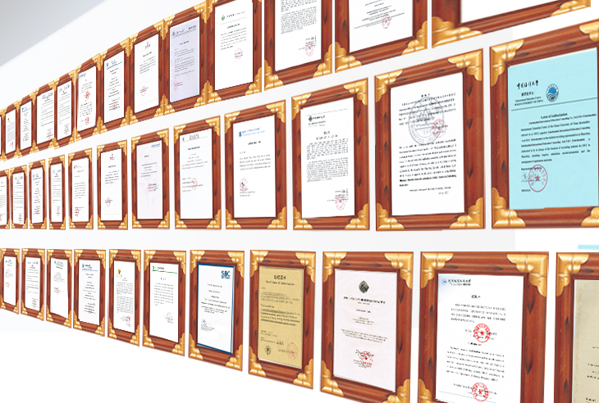
Authorizations of China's Universities to SICAS

-- The Only Platform officially supported by Chinese Government & Ministry of Education (MOE)"Study In China" Project and authorized by nearly 300+ China's Top Uni.
-- China Uni. Assure the priority to applications sent through SICAS and offer the fastest admissions to SICAS applicants by issuing Admission Letter through their own "SICAS Uni. Staff Account" directly
-- More than 35,000+ courses are searchable on SICAS, which are officially updated by 300+ universities through their "SICAS Uni. Staff Account"

